INTERNSHIP PROJECT REPORT
Submitted to
INLIGHNX GLOBAL PVT. LTD.
Bangalore, India

Date of Submission
15/01/26

Customer Churn Prediction System
Model: DecisionTreeClassifier, RandomForestClassifier, XGBClassifier

Prepared by
Nadar Deepthi Chenthil
AI & ML Intern
ITID5802

Internship Duration
15/11/25 – 15/01/26

Index
Sr. no. | Contents | Page no.
1 | Introduction | 3
2 | Libraries and Dependencies | 3
3 | Dataset Overview | 4
4 | Data Loading | 4-6
5 | Data Pre-processing | 6-9
6 | Feature Scaling | 9
7 | Train-Test Split | 9-10
8 | Model Building | 10-11
9 | Model Evaluation | 11-12
10 | Cross-Validation | 12-13
11 | Prediction on New Input | 13-14
12 | Project Workflow Summary | 14
13 | Conclusion | 14-15

Link to GitHub with the .ipynb file containing the implementation code, all dataset .csv files and documentation:

https://github.com/Deepthi-Nadar/Customer-Churn-Prediction-System-Using-ML/blob/main

Customer Churn Prediction System

1. Introduction
Customer churn prediction is a critical business problem, especially in industries like telecommunications, banking, SaaS, and subscription-based services, where retaining existing customers is more cost-effective than acquiring new ones.
This project focuses on building a Customer Churn Prediction System using machine learning techniques. The system analyzes historical customer data and predicts whether a customer is likely to leave the service (churn) or continue.
The notebook Customer_churn.ipynb implements a complete end-to-end ML pipeline, starting from raw data loading to model saving for deployment.

Problem Definition
- Input: Customer demographic, service usage, and billing information
- Output: Churn prediction (Yes / No)

Type of Problem
- Supervised Learning
- Binary Classification Problem

Business Importance
- Helps companies identify at-risk customers
- Enables proactive retention strategies
- Reduces revenue loss

2. Libraries and Dependencies
The notebook uses the following Python libraries:
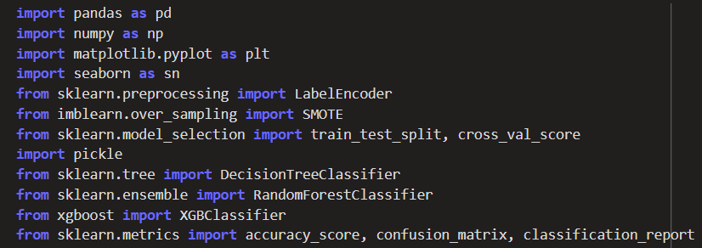
- pandas – Data loading and manipulation
- numpy – Numerical operations
- matplotlib / seaborn – Data visualization
- sklearn (scikit-learn) –
  - Preprocessing (LabelEncoder, StandardScaler)
  - Model building (Logistic Regression / Random Forest / etc.)
  - Model evaluation (accuracy, confusion matrix, classification report)
- pickle – Saving and loading trained models and encoders
These libraries together form the backbone of the machine learning workflow.

3. Dataset Overview
The dataset contains customer information commonly found in telecom churn datasets.

Key Features
Feature | Description
gender | Customer gender
SeniorCitizen | Whether the customer is a senior citizen (0/1)
Partner | Whether customer has a partner
Dependents | Whether customer has dependents
tenure | Number of months the customer stayed
PhoneService | Phone service subscription
InternetService | Type of internet service
OnlineSecurity | Online security subscription
TechSupport | Tech support subscription
Contract | Contract type
MonthlyCharges | Monthly bill amount
TotalCharges | Total bill amount
Churn | Target variable

4. Data Loading
The dataset is loaded using the pandas library, which provides powerful data manipulation capabilities.

Steps Performed

- Import the dataset using pd.read_csv()
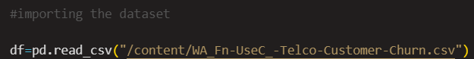
Store the data in a pandas DataFrame
- Perform initial inspection using:
  - df.head() – Displays first few rows
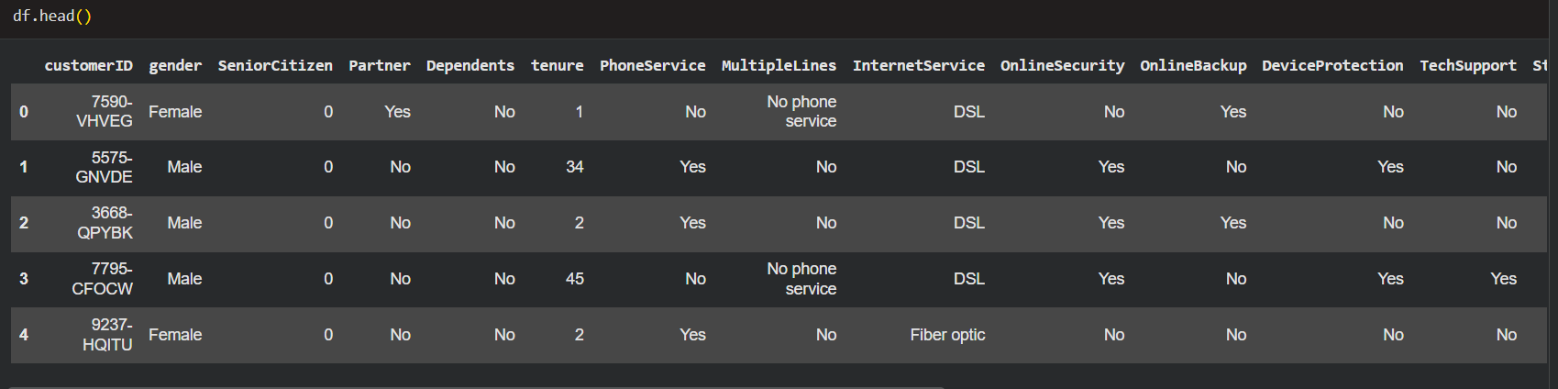
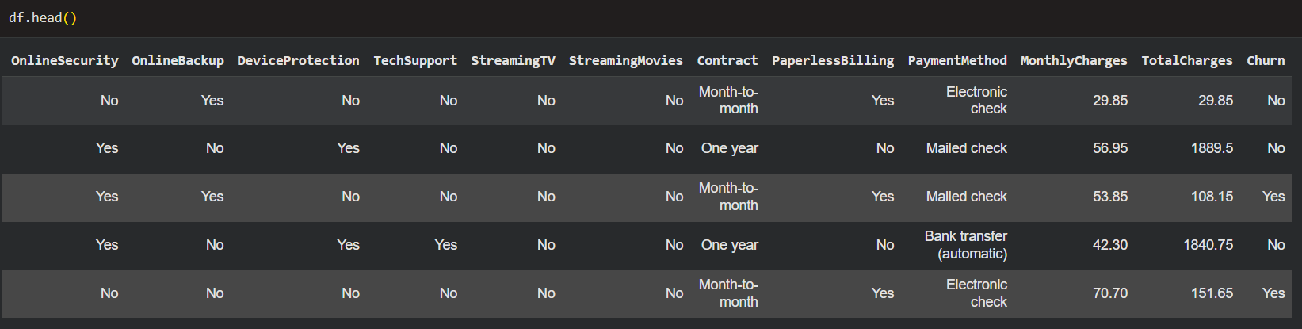

  - df.shape – Shows number of rows and columns
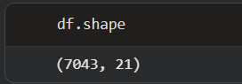

  - df.info() – Displays data types and null values
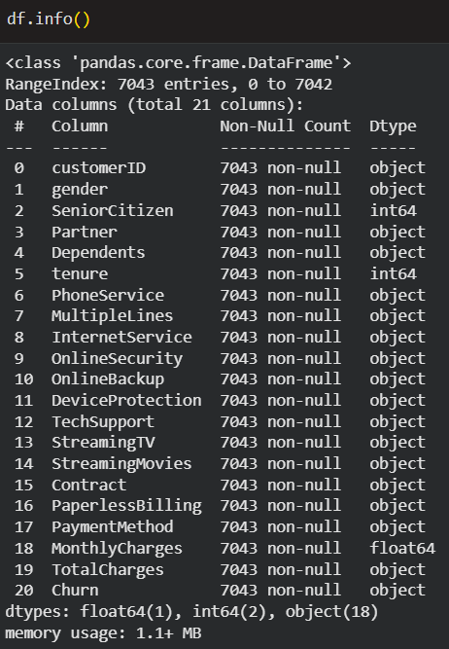

  - df.describe() – Statistical summary of numerical columns
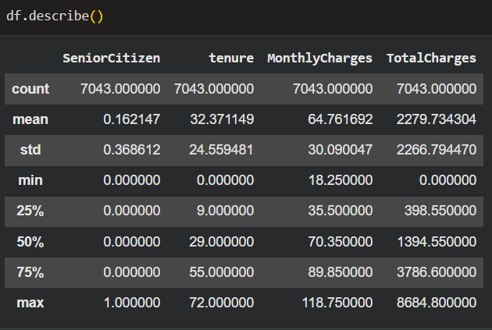

Purpose
- To understand the structure of the data
- To identify missing or incorrect values
- To verify column names and data types

5. Data Pre-processing
Data preprocessing is one of the most important steps in any machine learning project. The quality of preprocessing directly impacts model performance.

5.1 Handling Missing Values
- Certain columns like TotalCharges may contain blank or non-numeric values
- These values are converted to numeric using pd.to_numeric()
- Rows with invalid or missing values are either:
  - Removed, or
  - Imputed based on project requirements

5.2 Dropping Irrelevant Columns

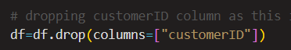
- Columns such as customerID do not contribute to prediction
- These columns are removed to avoid noise in the model

5.3 Encoding Categorical Variables
Machine learning models cannot work directly with categorical (text) data.
Steps followed:
- Identify categorical columns (object data type)
- Apply Label Encoding to convert categories into numeric values
- Store each encoder in a dictionary for reuse
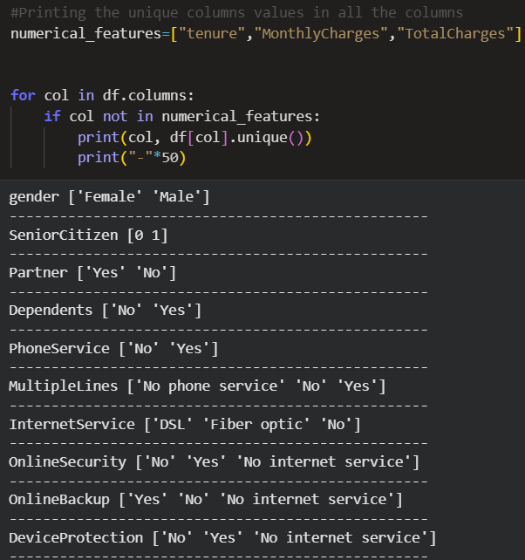
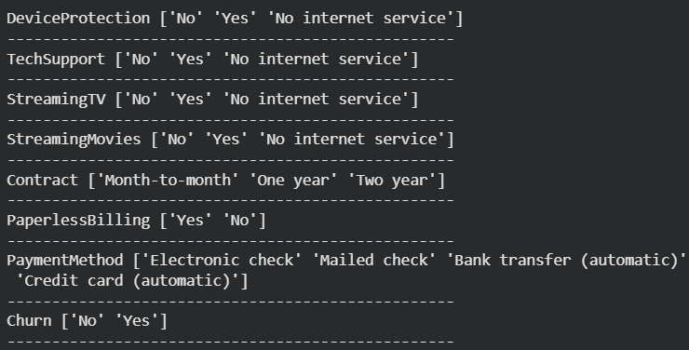
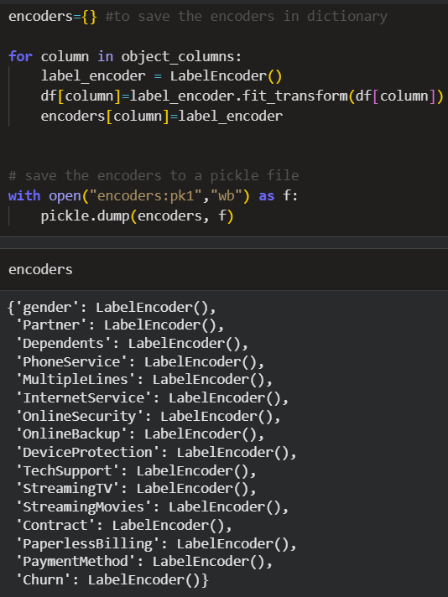
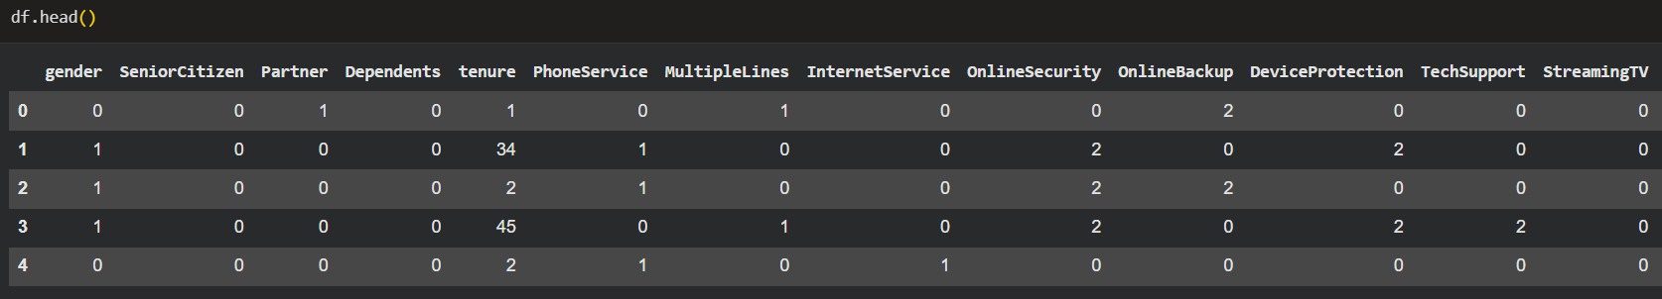
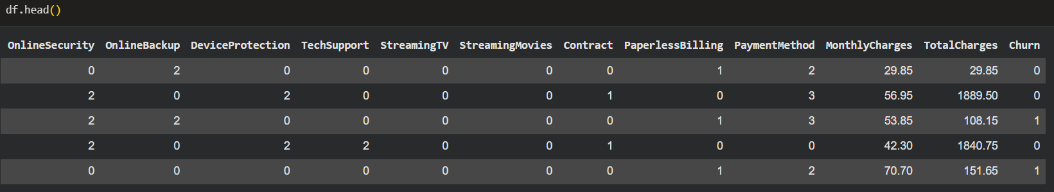
Saving encoders ensures consistent transformation during future predictions.

6. Feature Scaling
Feature scaling is applied to numerical features so that all features contribute equally to model training.

Why Scaling is Required
- Prevents dominance of large-value features
- Improves convergence speed
- Enhances performance of distance-based models

Scaling Technique Used
- StandardScaler from scikit-learn
Formula applied:
Z = (X - μ) / σ

Scaled Features
- tenure
- MonthlyCharges
- TotalCharges
The same scaler must be reused during prediction to maintain consistency.

7. Train-Test Split
The dataset is split into:
- Training set (e.g., 80%)
- Testing set (e.g., 20%)

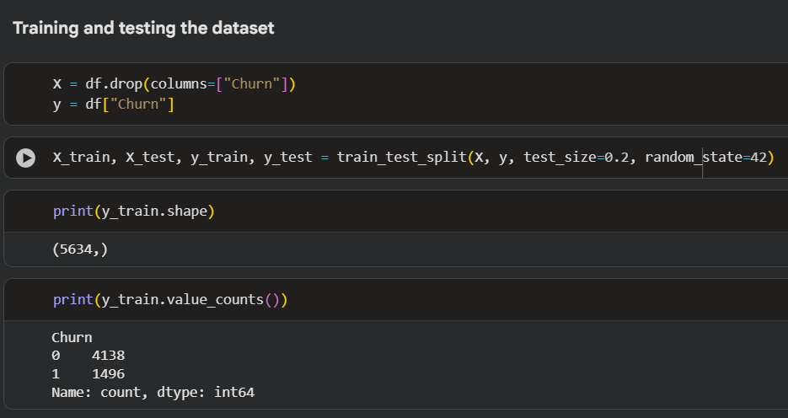
This ensures unbiased evaluation of the model.

8. Model Building
After preprocessing, the cleaned dataset is ready for model training.

Model Selection
Churn prediction is a classification problem. Common algorithms suitable for this task include:
- Logistic Regression
- Decision Tree Classifier
- Random Forest Classifier
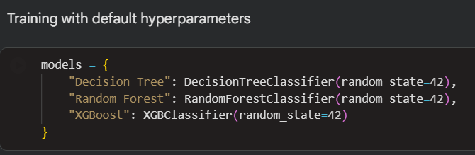
The chosen model learns patterns between customer attributes and churn behavior by minimizing classification error.

Training Process
- Initialize the model with suitable hyperparameters
- Fit the model using training data (X_train, y_train)
- Store the trained model in memory for evaluation
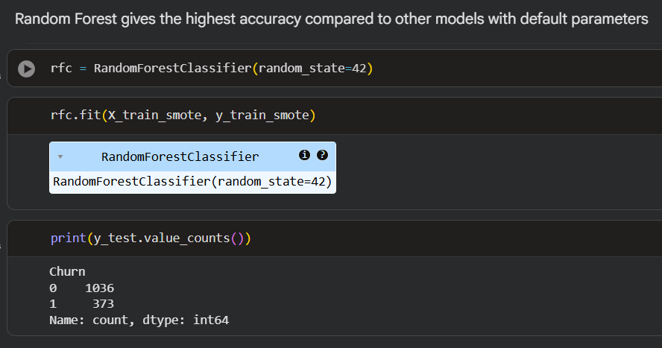
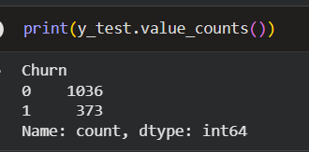

9. Model Evaluation
Model evaluation helps determine how well the trained model performs on unseen data.

9.1 Accuracy Score
- Represents the percentage of correctly classified instances
- Easy to understand but not sufficient for imbalanced datasets

9.2 Confusion Matrix
The confusion matrix provides a detailed breakdown:
Actual / Predicted | No Churn | Churn
No Churn | True Negative | False Positive
Churn | False Negative | True Positive
This helps analyze specific types of errors.

9.3 Classification Report
Provides advanced metrics:
- Precision – How many predicted churns were correct
- Recall – How many actual churns were detected
- F1-score – Balance between precision and recall
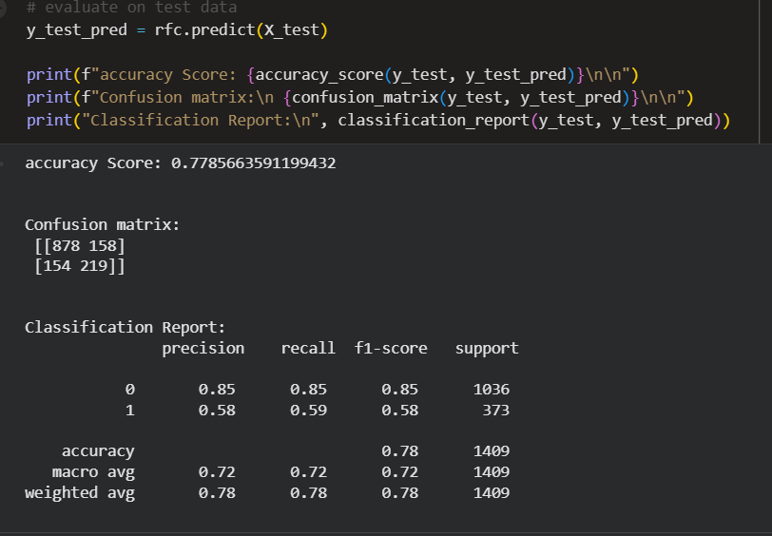

10. Cross-Validation

What is Cross-Validation?
Cross-validation is a technique used to evaluate model performance more reliably by training and testing the model on multiple subsets of data.

Technique Used
K-Fold Cross-Validation
- The dataset is divided into K equal parts (folds)
- The model is trained on K-1 folds and tested on the remaining fold
- This process is repeated K times
- Final performance is averaged across all folds

Why Cross-Validation is Important
- Reduces dependency on a single train-test split
- Detects overfitting and underfitting
- Provides more stable performance estimates
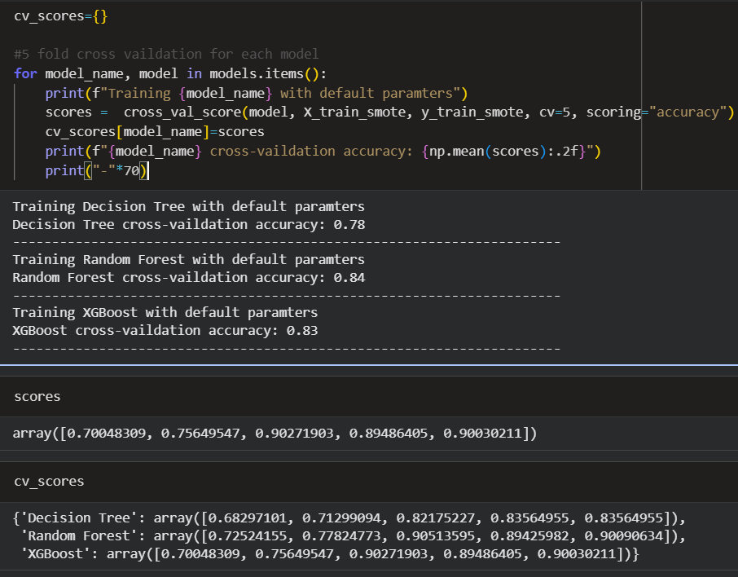
Cross-validation confirms that the Logistic Regression model generalizes well.

11. Prediction on New Input
New customer data is:
- Converted to DataFrame
- Encoded using saved encoders
- Scaled using the same scaler
- Passed to the trained model
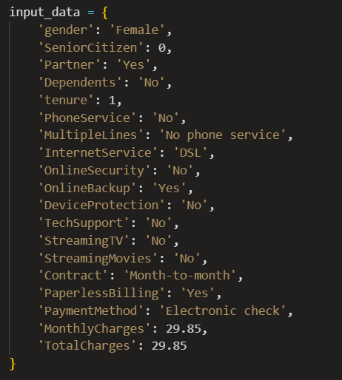

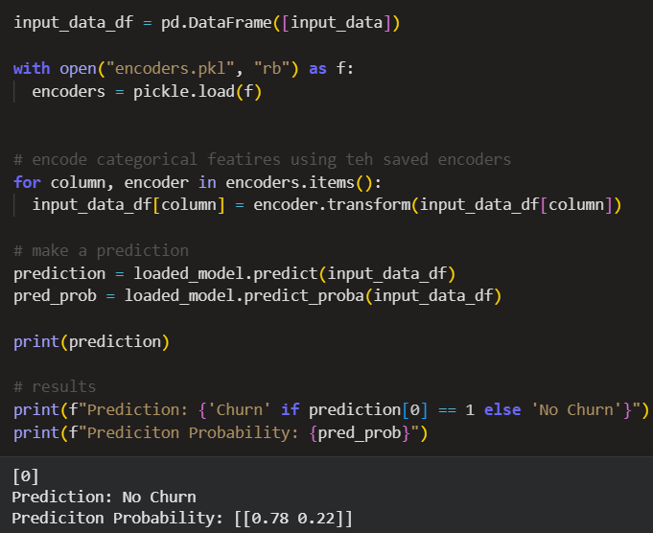

12. Project Workflow Summary
Data Collection
↓
Data Cleaning
↓
Encoding & Scaling
↓
Train-Test Split
↓
Model Training
↓
Model Evaluation
↓
Save Model & Encoders
↓
Prediction on New Data

13. Conclusion
This notebook demonstrates a complete end-to-end customer churn prediction system, covering:
- Data preprocessing
- Feature engineering
- Model training
- Evaluation
- Model persistence
It can be extended further by:
- Hyperparameter tuning
- Trying advanced models (XGBoost, Neural Networks)
- Deploying using Flask/FastAPI

